Reggie demonstrates peeling the film off the disc using masking tape.
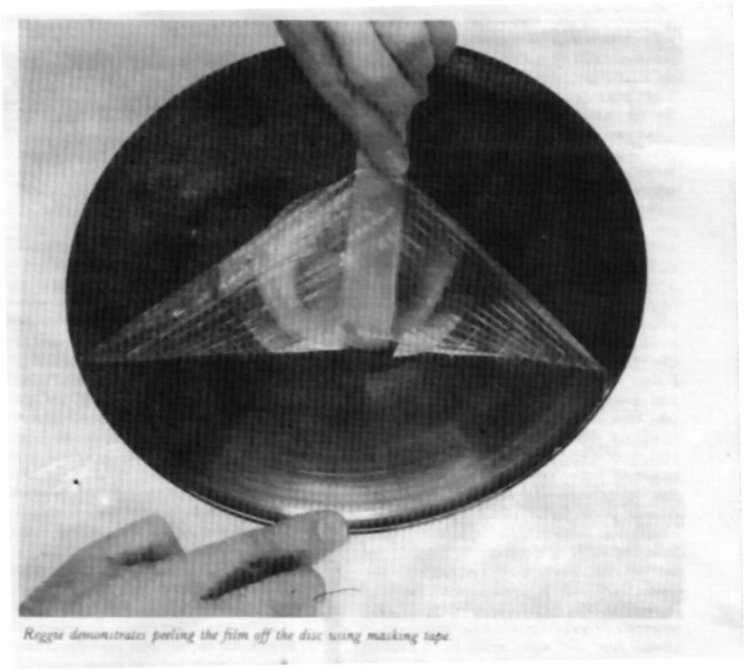

is sometimes used as a packing material when the contents are to be dissolved in water—for that is its other virtue, being solvent in water. Very unusual, and you can’t get an’ything more inert then H20! Polyvinyl Alcohol or PVA is used also in the paper industry and is produced by hydrolyzi.ng a sticky material, much used in modern glues, called polyvinyl acetate.
Since stickiness is the last quality we need in our PVA, the grade we need is that which is “fully hydrolyzed.” PVA is available under various trade names and I will quote a few: Alvyl, Gelvalol, Mowiol, Polyviol and Eloanol. Sometimes, the degree of hydrolyzation is men tioned in a code number which follows the trade name. A second number fol lowing will also indicate the degree of viscosity of a 4% aqueous solution in centipoises. Don’t worry about the tech nicalities, but a 90-50 grade will be well hydrolyzed and of medium viscosity, in solution about the consistency of warm molasses.
Whilst I have tried a wide variety of PVAs from many commercial sources, the one I have found quite uniform and that gives satisfactory results is the Du Pont product Elvanol. The grade used is a medium viscosity type 85-82. But I must emphasize that other grades and other makes are likely to be equally suit able and all that may be needed is some slight adjustment to the proportions in solution. So it is worth saying a word or two about that. The limit, I would sug gest, is a 10% solution of PVA in water. If this produces when cold a solution that flows with sufficient ease when you come to brush it on the record surface (I’ll be talking about that later) then it is good enough. Varying the solid to liquid proportions will alter the viscosity—but I don’t recommend higher than 10% solids since there is a tendency for it to jellify in solutions stronger than this. It
• will liquefy quickly when warmed, but can be avoided altogether if possible. Now for the preparation of the solution. Assemble all your materials in a clear working space in the kitchen. Keep your wits about you in preparing the mixture and you should have no problems. In addition to the PVA you will need gly cerin, distilled water, a wetting agent, and a small quantity of denatured alco hol.

MAKING IT
YOU will need a clear glass Pyrex con tainer: a double-boiler or perhaps a Py rex measuring cup in a large size. It should not be less than 500cc (about one pint). You will place this in a saucepan of cold water which will be brought to the boiling point. Pour into the cup or top of the double boiler about 400cc of pure water, not water from the faucet. Again, as in the case of the antistatic preparation (TAA, 2/81, p. 19), it can be
either deionized or thawed ice collected from the coils next time the freezer is de frosted. A dehumidifier machine, if the receptor tray is kept clean, will provide what is essentially ‘‘distilled’’ water for the purpose. It is vitally important that the water has a pH neutrality, since even small degrees of acidity or alkalini ty will vary the viscosity quite a lot.
Now add 50 gms of PVA which comes as a white to cream powder, adding a lit tle at a time to the cold water while stir ring it with a clean spoon or stirring rod. This will prevent clumping of the pow der in the water.
Now stand the measuring cup in the pan of cold water and stir it as the water heats to a boil. The slurry should rise to a temperature of 90~95 centigrade, and as it does will start to dissolve, changing its appearance quite significantly. It will vary from a milky consistency to a clear solution with low viscosity (which will thicken as it cools) and rather depends upon the make. But in any case, be quite sure you don’t stop stirring until you are confident that all the free solids are fully dissolved. I might add, you can’t overdo it.
Allow the dissolved PVA solution to cool after adding enough extra water to bring the total solution to 500cc. [About 17 oz.] Very useful additions are about
10cc of glycerin to make the film more pliable and soft if your make of PVA as a tendency to stiffness. The “facial" is easier to apply if a surfactant is added. One of the proprietary brands of photo-
graphic wetting agent is useful here. I have found about 3-4 drops of M&B C’ascade ideal for this, which also goes un der the trade name of Nonidet, made by Shell Chemicals, U.K. [Kodak’s Photo Flo 200 works well also.—Ed.] And fi nally, you can add up to 10% of dena tured alcohol to the final mixture whilst it is still warm and of course, stirred tho roughly. This has the virtue of both in hibiting the tendency to jellify and to hasten drying. Again, the actual propor tion of alcohol to mixture is rather de pendent upon the particular grade of PVA used.
I need hardly to remind readers that denatured alcohol may be subject to re strictions by the Internal Revenue Ser vice and its purchase. storage and use subject to licensing. The ordinary min eralized grade methylated spirit that one can purchase without license is not suit able.
When cool, the solution should be either clear or slightly milky and is ready for use. Which brings us finally to the method of application. Assuming that you have already tried the antistatic treatment, you now need a small plinth on which you will be supporting the rec ord and no bigger than the record label area. It should be reasonably horizontal, obviously. Keeping the record firm on the plinth with the fingers of one hand, pour a small bead of solution all around the center of the recorded area.
The actual amount comes with prac tice, but if too much it will take a very

